Bug Id :Bug_002.
Title : Email id getting accepted without domain extension (.com,.net,.in).
Module :Add User and Edit User
Step to Reproduce :
1.Login in to Dashboard
2.click on Add user /Edit User
3. Enter the email id without domain extension likes .com or .in or .net

Expected Result : An error message should be displayed indicating that Enter valid email address .
Actual Result : User is Successfully getting created /Edited
Severity : Medium
Priority: High

Proof of Document :
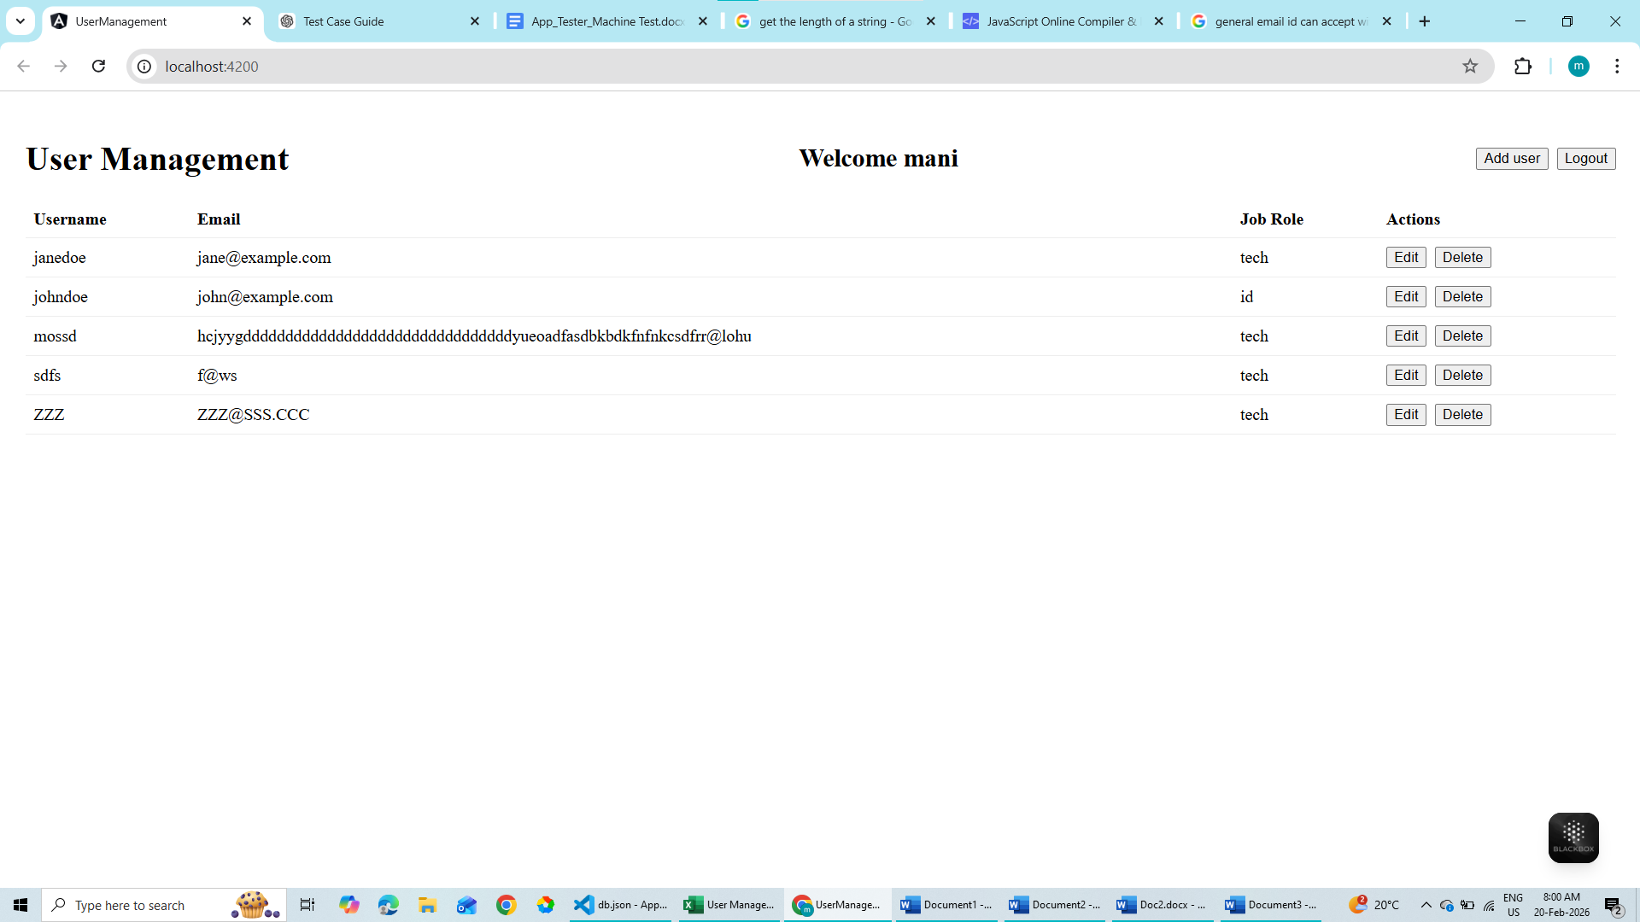
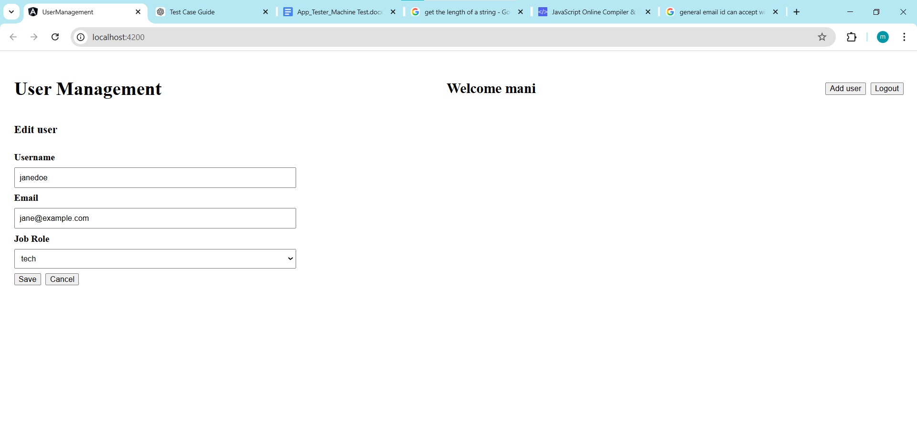
Enter the email without domain extension
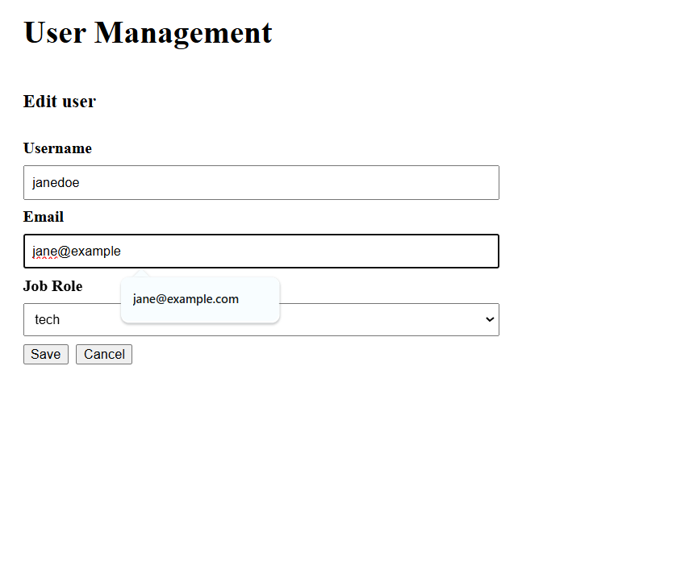
It got Updated in User Management Page

It got Updated in DB as well

